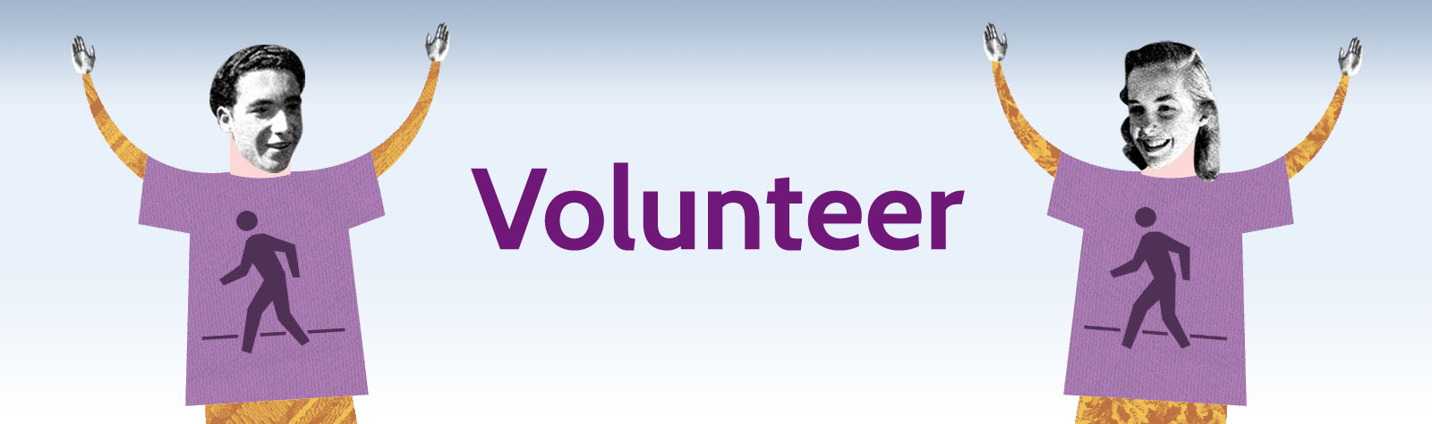

Volunteer Application Form

Borderline, Borderline Art and Borderline Theatre (now collectively known as Borderline Arts) were all projects founded and instigated by Sarah Eley.
In all we do, our goal is to nurture creativity and raise awareness of and reduce stigma surrounding Borderline Personality Disorder (BPD).
Please visit our website for more information and email volunteer@borderlinearts.org to sign up to the mailing list: www.borderlinearts.org
As an organisation we are growing and developing all the time, and our success relies on the enthusiasm and hard work of a group of committed volunteers.
This form is designed to help you consider the volunteer role you are interested in taking within Borderline Arts. There is a range of short and long term volunteer opportunities available.
In return, we are offering volunteers the experience of working within a growing dynamic and successful mental health focussed arts organisation. Borderline Arts will provide ongoing support and a reference to help your future career.
We will make every effort to offer a range of experience and match individuals where possible to particular areas of interest. We are interested in volunteers from all backgrounds and areas of the community.
Please email us your CV (if you have one) as well as completing this form.
For any queries please contact: volunteer@borderlinearts.org

Application deadline is _______________
Interviews will be held in the week commencing ________________
(N/A if no date is entered)
Contact Details

Sex:

- Female
- Male
- Transgender
- Prefer not to say
- Other

Full Name:

h

What is your current understanding/experience of BPD? (Tick all that apply):

- I don't know anything about BPD at all
- I know a small amount
- I know quite a bit
- I know a great deal
- I have a diagnosis of BPD
- I work with individuals with BPD
- I have a friend/partner/family member with BPD
- Other (please state): ____________________

How did you hear about Borderline Arts?

- Our Website
- Our Social Media Accounts (e.g Facebook, Twitter etc)
- Awareness Stall
- Flyer/Poster
- Website Manager
- Word of Mouth
- Other (please state): ____________________

Address:

Phone Number:

Email Address:

Date of Birth:

Volunteering with Borderline Arts

Please tell us about any work experience you have that is relevant to Borderline Arts and/or the role you are applying for:

Please tell us about any relevant qualifications you’ve gained (including any you are currently studying towards):

What draws you to volunteer with Borderline Arts?

Please tell us about any skills/qualities you feel you can bring to the Borderline Arts Team:

Please select the role(s) you’re applying for:

- Volunteer Coordinator
- General Administrator
- Workshop Administrator
- Workshop Facilitator
- Website Manager
- Social Media Coordinator
- Bank Volunteer
- Other (please state): ____________________

Getting to know You

Please use this space to tell us more about yourself (personality, interests, hobbies etc):

Do you have any health/social issues etc that we need to be aware of:

Availability

X

Do you have any existing commitments, e.g job, family etc? (Knowing this helps us to take these into account when delegating/roles tasks etc):

Please tick the time(s) you’re available to volunteer:

- Mornings
- Afternoons
- Evenings
- Weekends
- Weekdays
- Flexible
- Other (please state): ____________________
J

Do you have a current DBS Check?

- Yes
- No
- Unsure
G

What date (roughly) would you be free to start?

Please email your completed form and your CV to: volunteer@borderlinearts.org or post to: Borderline Arts, Volunteer Coordinator, 119 Osmaston Road, Derby, DE1 2GD.

We look forward to receiving your application!

